## School Summary

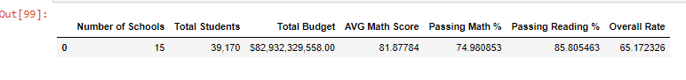

## District Summary (head)

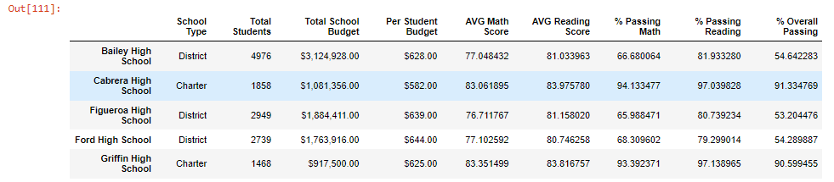

## Highest-Performing Schools (by % Overall Passing)

## 

## Bottom Performing Schools (By % Overall Passing)

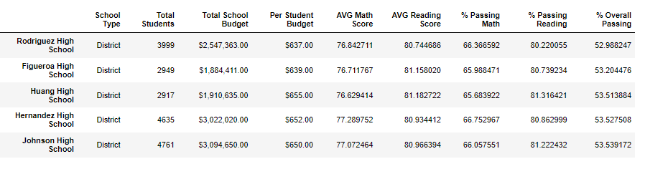

**Conclusion #1:** Charter schools are outperforming district schools. The top 5 performing schools were charter schools while the bottom 5 performing schools were district schools.

## Math Scores by Grade

## 

## Reading Score by Grade

## 

## Scores by School Spending (head)

## 

## Scores by School Size

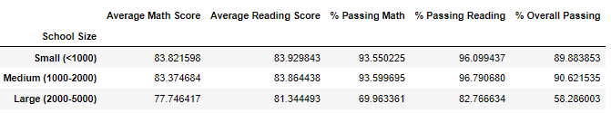

## Scores by School Type

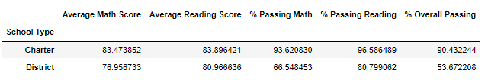

**Conclusion #2:** Charter schools have almost 40% higher rates of students passing both math and reading classes than district schools